Polarstern Energy – Sustainable Change
Led by Innovative Entrepreneurs

Abstract

In 2011 three young entrepreneurs, Jakob Assmann, Florian Henle and Simon Stadler, set out to revolutionize the energy market by offering a radical solution for customers to switch from non-renewable fossil fuels to renewable energies. Through their start-up Polarstern, they aimed to offer the first comprehensive sustainable energy package, derived from 100% renewable resources and at competitive price points to compete with the handful of large companies, which dominated this industry. The added global social dimension of their service provided a clear point of differentiation but communicating their innovative service to customers proved to be very challenging. The founders had to be entrepreneurial in their marketing approach to gain the trust of potential customers and to encourage their switching from their existing energy providers.

Case

It was a hot day, - “too hot for the time of the year”, thought Jakob Assmann, one of the founders of Polarstern, on the 1st of March in 2012 when walking into his Munich office. After the initial excitement of launching their own company, the three founders of Polarstern were struck with a communications conundrum. In the few months since entering the sustainable energy market, they had acquired very few customers, consisting mainly of family and friends. After many arduous meetings, the problem remained: how best to communicate Polarstern’s innovative and sustainable energy service to raise awareness and grow their business. The German energy market was dominated by a few corporate giants who proved to be fierce competitors for a new and small start-up company with limited financial resources and little recognition. The nature of the industry was also that their potential customers already were signed up with existing energy providers and so their energy needs were already being satisfied. Customer acquisition would rely on poaching customers from the giants. In order to do this, the founders knew that they had to find a way to communicate their complex service to customers and gain credibility and trust. Jakob had identified early on that this would not be a herculean task, since the majority of customers had little knowledge of the intricacies of energy production. They had tried different marketing activities already, but the three of them knew that they had to come up with a clear strategy immediately to utilise the quickly diminishing marketing budget and so an important meeting was set up in March 2012 to discuss the pillars of their sustainable marketing strategy.

HISTORY

Polarstern was founded in 2011 by Jakob Assmann and his two co-founders Florian Henle and Simon Stadler (Exhibit 1), fuelled by the passion to revolutionize the energy market and thereby contribute to sustainable development. A mutual friend, who knew that both of them were looking for an entrepreneurial opportunity to do something meaningful, introduced Jakob and Florian to each other. On reflection on the rationale for Polarstern, Jakob explained:

“We wanted to do something, felt that the energy market is an exciting one. There was already a kind of market focus, because I come from a family that had a background in the energy market and also my brother was in the energy market. I always thought that this market is very exciting and it is a market in upheaval. I find that really exciting. It is a highly competitive market that is still changing, where you can still change something and, most important: where you can do something good, something where you can foster a positive change. We wanted to push the change of technology in the energy market from fossil to renewable - even though it wasn’t clear at all at this time that this would actually happen”.

- Jakob Assmann, Co-Founder of Polarstern

It seemed obvious after studying the energy market that there was a lack of options for renewable energy sources for German consumers. Jakob remembered asking: “Why aren’t there any biogas products, even though biogas is at least as important as green electricity? Why is the energy turnaround only an electricity turnaround? That can’t be right! Why aren’t the other companies doing anything?” At the same time this perceived market failure represented an opportunity to bring about change towards renewables in their eyes. The young entrepreneurs felt that the energy market was a sector where they could “do something good, something where you can foster a positive change” and felt that in this area they could leverage their talents to contribute to sustainable development. Their initial idea was to offer biogas certificates to established energy providers, however, after several disappointing talks and failed attempts to partner with energy providers, they quickly realized that to really trigger a change in the anachronistic energy market they had to become an energy provider themselves, which marked the birth of Polarstern.

Their business model was built on the objective to provide the most sustainable service available in the energy market. They operationalized this ambitious aim by offering an inclusive package of green energy, enabling everyone in Germany to switch to renewable energy for a competitive and transparent price. The company’s offer consisted of two products for two sectors in the German energy market: 100% green electricity from German hydropower plants for the electricity market, as well as 100% green gas produced from the residuals of a sugar root factory in Hungary for the gas market. In entering the main energy sectors of electricity and gas, Polarstern added value to their products through global and social dimensions: for every customer in Germany, the company supported a family from Cambodia to build and maintain their own micro bio gas plant. This was built on the founders’ ideals to radically change the energy market and bring about the urgently needed transformation towards more sustainable lifestyles on a national and international scale.

THE GERMAN ENERGY MARKET

The German energy market at the beginning of the 21st century, like most energy markets worldwide, remained dominated by fossil fuels; first and foremost coal, oil, and gas. Due to their high energy density and low cost, fossil fuels were well-suited for the growing energy demands of the German population, yet the burning of fossil fuels resulted in an increase in CO2 emissions, which in turn increased greenhouse gases. The severe impact of energy production on the natural environment was seen as the primary contributor to global warming (Exhibit 2). Starting from the mid-20th century, also nuclear energy was used to satisfy parts of the energy demand and in 2011, 18% of the energy produced in Germany stem from nuclear power plants (Exhibit 3). While nuclear power produced less greenhouse gases and CO2 emissions as compared to fossil fuels, this form of energy production was highly contentious in Germany, due to the radioactive radiation, the nuclear waste and the politically sensitive risk of nuclear accidents. Thus, a cornerstone of the German energy policy was the phasing out of nuclear power and fossil fuels and the transformation to renewable energies by 2020 referred to as the “German Energy Turnaround” (“Energiewende”).

For a long time, the German energy market had been served by state monopoly, which prevented any free competition. Energy was seen as a “natural monopoly”, an industry characterized by extremely high fixed costs, mainly in form of large-scale infrastructure investments, and in which a duplication of infrastructure was seen as a loss of efficiency for a society. Therefore, governments aimed at discouraging new market entrants, and rather regulated the monopolists, ensuring that they did not exploit their market power. The natural monopoly of energy was supposed to change in response to EU directives, which was followed by the liberalization of the electricity market in 1998 and, later on, the gas market in 2006.

The liberalization of the German electricity market took place in 1998. Despite some initial difficulties, the green electricity sector grew rapidly, and competition continued to intensify over the next decades. When Polarstern entered the market in 2011, over 1000 electricity providers existed in the market, and 20% of the electricity used in Germany came from renewable resources (bdew, 20121, Exhibit 3). This impressive growth can be seen as a positive response to the “Erneuerbare-Energien-Gesetz” (EEG), and regarded by A.T.

1 bdew (2014). https://www.bdew.de/internet.nsf/id/83C963F43 062D3B9C1257C89003153BF/$file/Energie- Info_Erneuerbare%20Energien%20und%20das%20EEG%20%282014%29_ 24.02.2014_final_Journalisten.pdf

Kearney (20122) to show green electricity establishing itself as a mass market in Germany. The number of energy providers offering some kind of green energy products on the German market had increased enormously (Exhibit 4), but the offers varied greatly in composition, origin and price. Although some independent organizations already assessed and evaluated providers and their products, and consumers could rely on the labels such as “ok power“ or “TÜV,“ the plethora of different options had led to confusion and distrust. A study from 2012 found that 58.1% of all respondents had strong doubts that green electricity actually stemmed from renewable resources (Statista, 20123). Overall, the German electricity market was highly fragmented and characterized by a lack of transparency and consumer trust.

In contrast to the electricity market, however, the liberalization process was slow for the gas market. This was not only because new market entrants faced high entry barriers, but also because private customers were not allowed to choose their gas provider freely (Storck & Blatzheim, 20084). In 2006, as a response to strong cartel allegations, the gas market was finally opened up to allow for more competition and innovation, and since then the competition on the gas market had steadily increased. The market had seen an intensification of competition, with the number of green gas providers nearly tripling between 2009 and 2011 (with 55 gas providers at the end of 2011, Exhibit 4). Furthermore, having researched the few available products in the gas market, the founders of Polarstern discovered that only a minority of the products actually stemmed from 100% renewable resources. In most cases, 50% were solely based on climate compensation charges, which meant that the gas itself was still coming from fossil sources. About one third of the green gas products comprised of only 5-20% gas from renewable resources - most of them with conflicting uses - while the rest was still fossil gas.

THE SUSTAINABLE INNOVATION OF POLARSTERN

At the start in 2011, Polarstern’s services were offered through a website, where customers only needed to provide their details if they wanted to switch from their electricity and/or gas provider to Polarstern. The switch itself, including the cancellation of the contract with the current energy provider, was taken care for by Polarstern. The user-interface was plain and straightforward to keep the process as simple as possible for the customer and the
2 ATKearney (2012). http://www.atkearney.de/documents/856314/1214638/BIP_Der_Strom_ und_Gasvertrieb_im_Wandel.pdf/ee091e7c-9406-4b23-b5b3-608f936cbecc
3 Statista (2012). http://de.statista.com/statistik/daten/studie/235572/umfrage/vertrauen-von-verbrauchern-in-die-herkunft- von-oekostrom/
4 Storck, T. & Blatzheim, H. (2008). http://www.verivox.de/ratgeber/10-jahre-gasmarktliberalisierung-25547.aspx

information was presented in a way that created a positive feeling about the switch instead of targeting or speaking to the bad conscience of potential customers. As Jakob stated:
“And then we started to develop more and more sustainable, socio-ecological service attributes because we wanted to develop the best service available on the market. What we did was looking at: how does the maximum change look like, what kind of sourcing do we need, meaning where do we buy it from, how do we calculate our prices, and so on. All the things you need to create an ideal business.”
-Jakob Assmann, co-founder of Polarstern

Jakob was proud that Polarstern had developed a highly innovative business model for sustainable energy, which was based on three cornerstones:
- Energy from 100% renewable resources;
- Transparent and fair prices for renewable energies;
- Real change towards sustainability on a global level.

He remarked: “It was all about how could we implement a business that can sustain itself - but in an economically, ecologically and socially sustainable way? And if you have an answer to this question, you just have to build a business model around it. You need to keep it lean and simple.”

Energy from 100% renewable resources

Having conducted a comprehensive competitor analysis, Polarstern decided to offer two products for the energy market: green electricity and green gas. Both products were from 100% renewable resources. This was a major point of differentiation from most of their competitors, who mainly relied on compensation models where energy providers set off their CO2 emissions, for example by planting a tree, while still relying on fossil fuels. The three founders wanted to be able to ensure that 100% of their energy was sustainably produced, which also meant that they only used energy sources which already existed, for example, the river in Feldkirchen which was used for the electricity production. Jakob remembered how they had visited and selected the production sites and how difficult it was to find partners that shared their vision of a sustainable future: “we wanted to offer an all-round package - gas and electricity - to allow for 100% change.” Polarstern’s green gas product was the first one on the German market made of 100% organic residuals with non-conflicting uses, as they stemmed from a Hungarian sugar root factory and were processed in a bio gas plant directly next to the factory, thereby not causing any additional CO2 emission through transportation (Exhibit 5).

Transparent and fair prices

Jakob and his two co-founders shared the vision of enabling every customer to switch to renewable energies, because of their conviction that green energy should not be a luxury product. This approach was particularly significant for the energy market, where the price still played a crucial role for the customers: “We know that the price is still very important if you want to succeed at the market, and to really create a market you need to make it price competitive.” Therefore, an important component of their business plan was to provide renewable energies at affordable and competitive prices, which became possible due to the innovative intelligent electricity and gas trading system developed by the founders. To ensure a high transparency of their calculations the founders relied on a set of conditions: stable prices, i.e. Polarstern calculated the price for one year and did not change it until the end of the year; calculations based on the real energy usage, i.e. the customer only paid what s/he really used; and high flexibility, i.e. the customers were offered the possibility to cancel the contract at any time.

Real sustainable change on a global level

Furthermore, the founders always felt that the energy turnaround was a global issue, which does not stop at the German border. Therefore, the global perspective constituted an integral part of their business plan as well. While fair trade had increased in popularity among several industries, Polarstern’s “one-for-one“ social approach was an innovation in the energy sector. Working together with a local partner, the National Biodigester Programme5 (NBP) Cambodia, Polarstern promised that with every new customer, they would support a family in Cambodia to build their own micro bio gas plant with local natural resources, thereby contributing to a worldwide energy turnaround.

At that time, the dominating energy sources in Cambodia were firewood and petroleum, which led to deforestation and high CO2 emissions. Furthermore, many families had limited access to toilets and the excrements were simply disposed of anywhere, resulting in ground contamination and the spread of diseases. The micro bio gas plant that Polarstern customers supported provided the family not only with energy and a connected toilet, but also utilized manure and other residuals that could have led to diseases otherwise (Exhibit 6). The founders chose to engage in a cooperation with the NBP as the organization encouraged the autonomy of the Cambodian family: for each customer, Polarstern provided the knock-on financing of $150, while the remaining $400 had to be financed by the families themselves

5 National Biodigester Programme: http://nbp.org.kh/

(with the help of micro credits), to give them a feeling of ownership and responsibility of their plant.

By supporting the NBP, the founders realized their vision of initiating a positive change on a global level. Simon stated “I thought that this was really cool. First of all, from an impact point of view: we can really change something, and on the other hand, as a tool to arouse people’s interest and to say: hey, it is not just about getting your energy bill from yet another company and then hoping that everything is good now. But rather about having an impact with your decision and thereby convincing even more people to go for green energy.” To ensure that the organization performed as promised, the founders and some of their customers visited the projects in Cambodia on-site on a regular basis. Furthermore, the founders could rely on a personal contact, who had participated in an audit of the NBP project and thus trusted, that the money was well invested in the Cambodian project.

Having designed their sustainable innovation, it was crucial to then communicate their innovative sustainable service to potential customers.

MARKETING AND COMMUNICATION @ POLARSTERN

At the time of foundation, there was no separate marketing and communication department, but all the tasks had to be fulfilled by the three founders personally. Jakob felt most enthusiastic about marketing because “this was where I knew: I can leverage my talents to achieve something. We could not just develop a new solar technology, but what we could do is use the language of advertisement and consumption goods to win over people for this topic.” However, his initial excitement was dampened by the slow process of entering the market. Jakob remembered their shared disappointment after they had launched their service. Florian got right to the heart of the matter: “And then, having entered the market, phew, you know, I think that happens to every founder: you’re working so hard towards launching your product - and then it’s online - and then... nothing. Nothing happens. It’s taking forever for anything to happen.“

From a marketing perspective the company faced several key challenges that jeopardized the existence of the young start-up:

The key challenge Polarstern was facing was to build awareness among their customer and to gain trust and credibility. Despite the fact that consumers consumed energy every day, there was only little knowledge and interest in the source of their energy supply. Even for sustainable-minded customers, the information provided was difficult to assess and,

therefore, hard to trust, particularly since there were no legal standards for the use of the terms “Ökostrom” and “Ökogas” (green and sustainable electricity and gas). Although some independent organizations already assessed and evaluated the services of energy providers, and consumers were able to rely on their labels, a consumer study revealed that 58.1% of all respondents had strong doubts that green electricity actually comes from renewable resources (Statista, 20126). Similar to the electricity market, the gas market was lacking transparency, but, unlike the electricity market, it was also lagging behind in awareness, which is why the need for information and consumer education was considerably higher for the gas product. For Jakob gaining trust and increasing transparency was a key requirement for the success of their service: “We need to explain the customer what it is all about, he or she needs to understand it, because only if we do that, the customer believes in our service and builds up trust.“

A major barrier in gaining trust and credibility was the low interest and involvement of customers in purchasing energy. In contrast to many other consumption goods, energy was not a product that was bought spontaneously or addressed consumers’ emotions. In a European study about customers’ willingness to switch service providers, electricity and gas were the sectors least prone to provider switching (Flash Eurobarometer, 2437). Yet, while energy consumption was a low-involvement process, the decision to switch, including the time to search for and compare energy suppliers, required high-involvement of consumers for them to master the difficult and time-consuming process. Furthermore, price sensitivity for obtaining energy was rather high, particularly as there was no tangible difference to the consumer when switching the energy provider, and although European citizens had a generally positive perception of renewable energies (Eurobarometer 4098), consumers feared that switching to renewable energies might pose a risk in the security of supply. Taken together, these reasons resulted in a very low willingness to change the energy provider (Exhibit 7), increasing the difficulties for the successful marketing of Polarstern’s service.
To build up trust and credibility, and to turn energy from a low-involvement into a high- involvement product, communication with customers was of utmost importance. Jakob was convinced that “we can’t master the energy turnaround if we’re not taking the customers along with us. That means that I have to interact with them, I need to work in a transparent way, the prices need to be fair, I need to be open with them, I need to work hard to build up confidence - I need to take the customer along with me.” However, the communication of such a multi-layered sustainable service, which offered three different value propositions and required explanation, led to difficulties in positioning the service. Although, their service was
6 Statista (2012). http://de.statista.com/statistik/daten/studie/235572/umfrage/vertrauen-von-verbrauchern-in-die-herkunft- von-oekostrom/
7 Flash Eurobarometer, 243: http://ec.europa.eu/public_opinion/flash/fl_243_sum_en.pdf
8 Eurobarometer 409: http://ec.europa.eu/public_opinion/archives/ebs/ebs_409_en.pdf

offered at comparable market prices, their main point of differentiation was that their energy stemmed from 100% renewable resources and at the same time supported a social cause. The founders had tried out different communication tactics already, but still struggled in clearly positioning their service. In the beginning they had tried to foreground the environmental and altruistic components of their product, while keeping the economic perspective rather in the background, later on they emphasized the economic value over the socio-environmental ones: “First, we tried to push the ecological aspect. Then, for some time, we tried to mainly promote the Cambodia project. So, we were kind of trying to figure out, which one works best for the customers.” While their unique selling proposition revolved around their ecological and social value added, the founders knew that the customers would only adopt their service when they were able to identify significant customer value as well.

In their quest to communicate and forge relationships with customers, the founders faced a challenge shared by most start-ups: limited financial resources, particularly to cover the high costs of marketing and communication. Jakob sometimes caught himself imagining what they could do with an unlimited budget, but the reality was that they had to effectively use their low budget by creating as many points of customer contact with as little money as possible, and utilize their own energy to get things running. Thus, the team knew that differentiating themselves from their competition and a straightforward positioning on the market was crucial to minimize waste coverage and thus, to allow for an efficient use of the limited resources.

KEY STRATEGIC DECISIONS

Jakob did not know for how long he had been staring at his desk. While he had been thinking about their situation he realized that “we had thought that the world had waited for us, but actually nobody was waiting; nobody wants to become a customer except for our parents. Yes, it is a disaster. You know, nobody knows you, you don’t have any money to gain publicity, people don’t trust you, you have to work hard to win people’s trust…” But he did not feel like he was ready to give up already. They had known from the beginning that starting a new venture would not be easy and had persistently worked hard to find the right strategy. Florian articulated the thoughts of all three founders in stating that: “It’s so tough. Especially in this sector we’re working in. It’s just tough. It’s an extremely high barrier to establish your business and the question is what it takes to be noticed at the market.” They had a number of alternatives to create their marketing strategy and the task at hand was to outline a recommendation that would best fit their young start-up. They were slowly running out of money, so the next investment in marketing needed to produce the desired effect and

finally bring in customers. On that day, they had planned a meeting to lay the foundation of their marketing strategy and Jakob wanted to organize his thoughts before the meeting. He took his pen and started writing down the key strategic choices to be made.

Segmenting and Targeting

The main questions that the three founders had debated over and over again were: What would be a promising customer segment for their service and what profile would their target customer have? Key decisions had to be made for customer segmentation and a recurring question with this regard was bustling in Jakob’s mind: “To whom do we offer our product?” To really understand their target group and to design a positioning and communication strategy, Polarstern needed to gain an in-depth understanding of their customers. While in general everyone could be seen as an energy customer, a market segmentation based on typical demographics did not contribute to a good understanding of the needs and wants of potential Polarstern customers. Thus, the founders had started to build customer profiles, which were based on behavioural and psychographic factors. In several team meetings, the founders had identified three relevant customer segments that held potential for the growth of Polarstern:

The green-and ethical-oriented customers
A high potential target group were what they had termed the green-/ ethical-oriented consumers, who likely already used renewable energies and who were very open towards sustainable products and services. Simon favoured this target group as these customers were the most frequent customers of green and fair-traded products and services and were willing to forgo their personal benefits in favour of the environment and society. While this target group promised quick gains, Jakob and Florian were somewhat hesitant as it was very limited in size and would only change consumer lifestyles on a small scale.

The lifestyle-oriented customers
Another promising target group were the lifestyle-oriented customers. These customers were usually a younger demographic and consumed products and services that would best fit with their lifestyle. Florian favoured the lifestyle customers, as he perceived the growing trend of health and sustainability as a promising growth market. The lifestyle-oriented customers were open towards products and services that promised to enhance their personal well-being and at the same time contribute to environmental and societal health. While this customer group was quickly growing in size, Jakob and Simon pointed to the intense communication and marketing efforts

that would be required to position Polarstern as a desirable lifestyle product in this segment.

The unconcerned customers
Alternatively, Jakob saw great potential in targeting unconcerned customers, with a low interest in sustainability. As this target group promised to have high-energy usage, convincing these customers to switch to renewable energies could really trigger a change towards more sustainable lifestyles. While this was still the biggest market segment in size, Florian and Simon called attention to the challenge to connect to the values of the unconcerned and to convince customers of the benefits of Polarstern’s sustainable service.

The three founders were aware that they needed a clear and common understanding of their target group in order to build and maintain relationships with customers, which in turn would determine the success of their start-up. Furthermore, their segmentation decision would strongly influence their positioning and communication strategy, thus determining the target group would set the base for defining Polarstern’s value proposition.

Defining the value proposition and positioning the service

The question of how to position their service was bothering Jakob. How should they define their key value proposition? Should they emphasize their green energy production from 100% renewable resources or better focus on the innovative one-to-one approach for supporting a Cambodian family? And how could they best address their customers’ wants and needs to create a real purchasing case as well? The difficulty in communicating their triple bottom line was to provide information that was specific enough to explain their unique selling proposition, while at the same time not to communicate too much information with the risk to overload the customer with information and thereby diluting their brand image. In their last meeting they had developed four possibilities for positioning their service. The first possibility identified was to focus their service on the socio-ecological value added (100% renewable energies, Cambodia project), which would capture a dominant position over performance and price. Another possibility was to put an equal emphasis on performance, price and socio-ecological aspects. Alternatively they could communicate the socio-ecological value as an integral part of product quality (i.e. 100% renewable energies and the Cambodian project contribute to the performance of the product). Lastly, Polarstern could refrain from communicating environmental and social benefits and focuses solely on performance and price.

The founders knew that the key challenge was to define a value proposition that was specific enough to separate them from their competitors, while at the same time did not overwhelm their customers with too much information. Only if they agreed on a clear value proposition and positioning strategy would Polarstern be able to effectively communicate to their target group.

Communication Strategy

In the end they still needed to decide how to bring their message across. Their market study had shown that customers were still fairly resistant to changing their energy provider, so communication was key in winning the trust of potential customers. They only had a limited budget, so traditional above-the-line advertising (i.e. mass media such as TV, print, radio) did not seem to be a realistic option, or was it? Jakob wondered whether this would be the only way to reach a critical mass of customers, or if they had other options as well? He outlined the possibilities for communicating their sustainable service: either Polarstern could focus their marketing spending to promote their service in the mass media (TV, billboards, radio, newspapers,…), thereby reaching a wide range of customers; or they could use their marketing budget for personal communication activities (social media, sponsorship, guerrilla marketing activities,…), thereby creating several contact points with customers.

STRATEGY MEETING

Jakob, Florian and Simon knew that they had to come up with a clear strategy immediately to utilise the quickly diminishing marketing budget. The meeting today was set up to discuss the pillars of their sustainable marketing strategy and each one of them had given a lot of thought to the key strategic decisions to be made. Simon was the last one to enter the room and closed the door behind him. It was time to start the meeting…

EXHIBITS
Exhibit 1 – Founder Profiles

Polarstern was co-founded by three entrepreneurs:



Jakob Assmann

“Hopefully it doesn’t get as worse as it already is”, said Karl Valentin. Then we have to start to change something together now, is what I say. In the end, it is my wish that the children of my children can live in such a nice world as we do. That they can still experience nature. By means of Polarstern we want to question the relation between environmental impact and energy consumption. Is this necessary? Does our life standard, the life we like to live, inevitably leads towards a global catastrophe? I’m afraid of the indifference of many people. For me, responsibility means, being aware of your own possibilities. Many possibilities – many responsibilities. And this is also the thought behind Polarstern: We provide the opportunity through which everyone can effortlessly make the world a little bit better.”

Dr. oec. publ. Dipl.-Business Administration Jakob Assmann (MBA, MBR) was research assistant at the Institute for Information, Organisation and Management at the LMU Munich, prior to founding Polarstern.

“I don’t like waiting. Better walk the talk - was what I thought. When the idea of Polarstern developed, I knew this is the opportunity. I live for a life in freedom. A life in which even in twenty years from now I can sit in a beer garden and drink a cold beer with my sons. At a time, when sustainable thinking has finally replaced the short-term pursuit of profits, and my sons will know words such as “lifetime extensions” and “bridging technologies” only from history books. Not everything was better in the past, but different. By means of Polarstern we want to contribute to the global energy turnaround. I would not presume to safe the world, but I want to be a small bright star at the energy sky – a clearly visible alternative at the horizon. And together we shine.”



Florian Henle

Dipl.-Business Economist Florian Henle (BA European Business (hons)) lived in Switzerland, where he developed regenerative resources in his function as Director of Business Development at NATOIL AG.



Simon Stadler
“At a perfect day I advance a lot, turn a round with my racing bike, then there is something good to eat in nice company, after that we go out for a drink for a good talk with friends – and still I sleep for seven hours… It’s true, not every day is a perfect day. 24 hours are often not enough. I live for the beautiful moments in life. In the past, yes in the past… everything was a little bit slower. But today we live in a time with extremely high life quality. Although, this might exactly be the reason that prevents us from changing something in time. Together, we consumers can thereby move a lot. I’m convinced of that and this is why I’m part of Polarstern. I want to determine the consequences of my actions myself.”

Dipl.-Economy Geographer Simon Stadler studied at the LMU Munich and afterwards worked at the Munich Landwärme GmbH as a project manager.

Source: www.polarstern-energie.de

Exhibit 2 – Greenhouse Gas Emission Trends in Germany
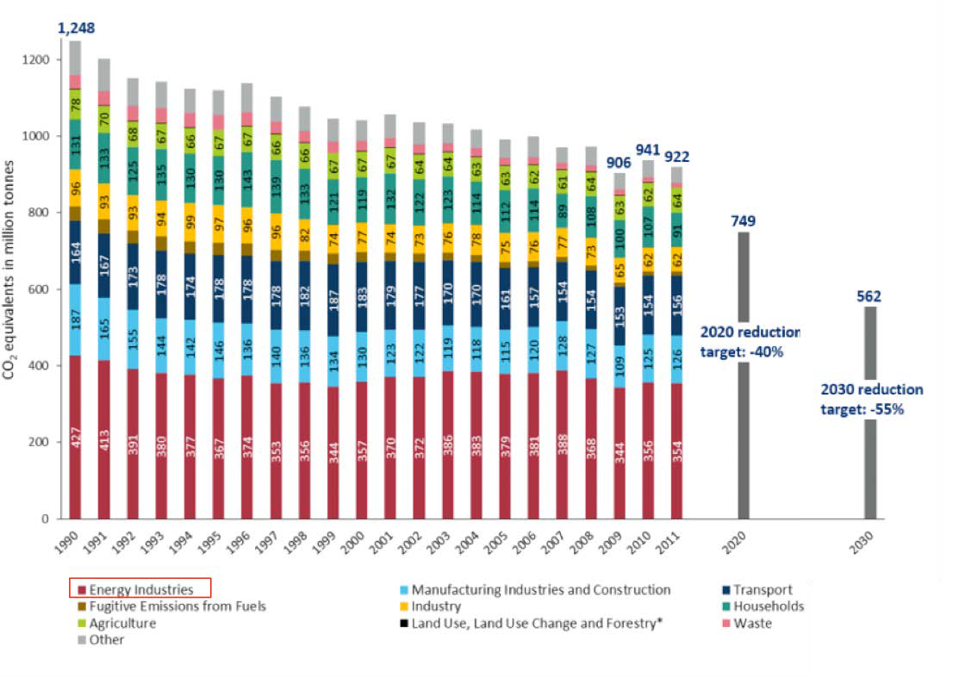
Source: Umweltbundesamt (Federal Environment Agency Germany), graphic adapted from www.cleanenergywire.org

Exhibit 3 – Germany’s Electricity Mix in 2011
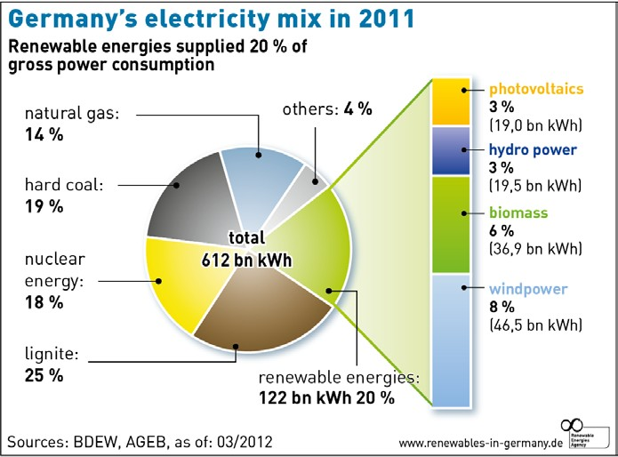

Sources: www.renewables-in -germany.de, based on data by BDEW and AGEB

Exhibit 4 – Current Supply Structure in Germany
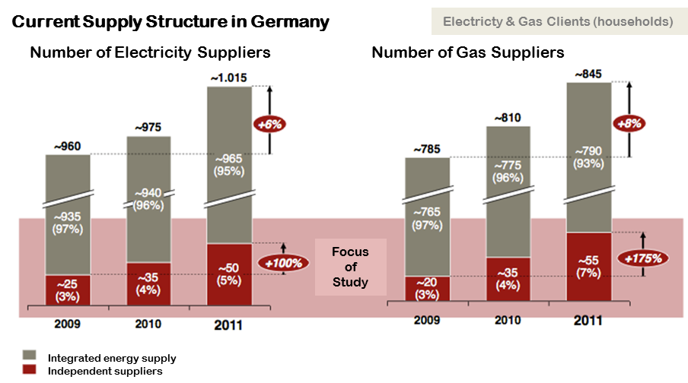

Sources: Verivox; Bundesnetzagentur; adapted from A.T. Kearney

Exhibit 5 – Hydropower plant and Hungarian root factory
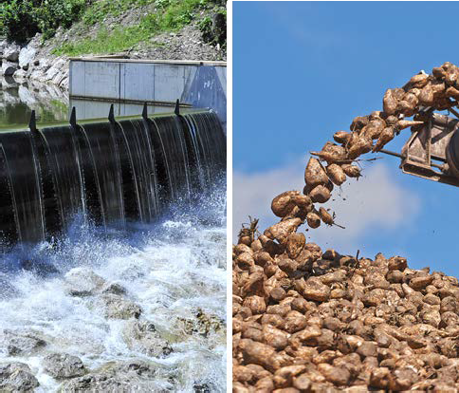
Source: www.polarstern-energie.de

Exhibit 6 – Microgas plant in Cambodia
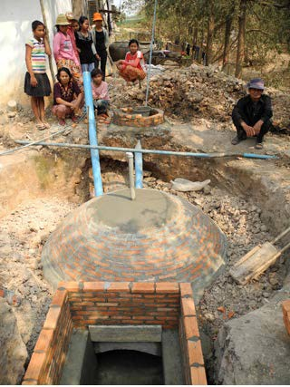
Source: www.polarstern-energie.de

Exhibit 7 – Projected Development of Customers Switching Energy Supplier
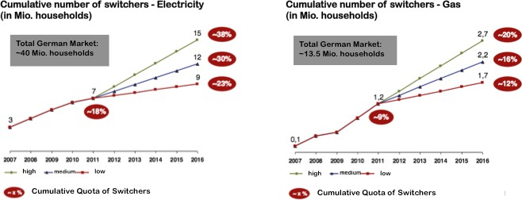
Sources: BDEW; Bundesnetzagentur; adapted from A.T. Kearney

